|  |
| --- |
| AIC, MATHEMATICS LEARNING AREA  **YEAR 12 MATHEMATICS APPLICATIONS – UNIT 4**  **Assessment Type: Response - 7%**  **TASK 9 - TEST 6 –** **Term 3, Week 7**  **CALCULATOR-ALLOWED**  **Syllabus Content: 4.2** Networks and Decision Mathematics |

Student Name: __________________________________________

ID: _______ Date: _______

**TIME ALLOWED: 1 period** under test conditions

**MATERIAL REQUIRED / RECOMMENDED FOR THIS PAPER:**

*TO BE PROVIDED BY THE SUPERVISOR*

Question/answer booklet.

*TO BE PROVIDED BY THE CANDIDATE*

*Standard Items:* pens, pencils, pencil sharpener, highlighter, eraser, ruler, calculator.

**IMPORTANT NOTE TO CANDIDATES**

No other items may be taken into the examination room. It is **your** responsibility to ensure that you do not have any unauthorised notes or other items of a non-personal nature in the examination room. If you have any unauthorised material with you, hand it to the supervisor **before** reading any further.

**Structure of this paper**

|  |  |  |  |  |
| --- | --- | --- | --- | --- |
| Section | Number of questions available | Number of questions to be attempted | Suggested working time (minutes) | Marks available |
| **Calculator Assumed** | **5** | **5** | **50 minutes** | **42** |
|  | | | **Marks available:** | **/42** |
| **Task Weighting** | 7% |

**Instructions to candidates**

* The rules for the conduct of this examination are detailed in the booklet *WACE* *Examinations*

*Handbook*. Sitting this examination implies that you agree to abide by these rules.

* Answer the questions in the spaces provided.
* Spare answer pages can be used. If you need to use them, indicate in the original answer space where the answer is continued.

**Question 1 (12 marks)**

A farm project consists of eight activities. The activities, their duration times (in hours) and the immediate predecessors for each activity are shown in the table.

|  |  |  |
| --- | --- | --- |
| **Activity** | **Completion Time** | **Immediate Predecessors** |
| A | 5 | None |
| B | 7 | None |
| C | 4 | A |
| D | 2 | B |
| E | 3 | C |
| F | 15 |  |
| G | 4 |  |
| H | 8 |  |

(a) By referring to the diagram below, complete the table above by filling in the 3 missing   
values in the last column.

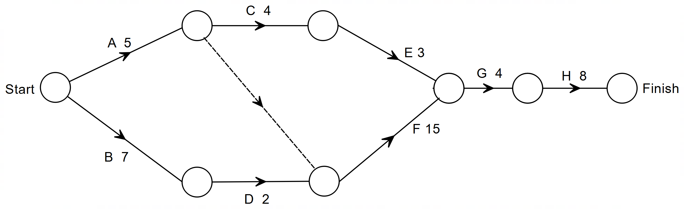 (3 marks)

(b) Complete the network below showing the earliest possible starting time (EST) and the

latest starting time (LST), where these are the top and bottom numbers respectively

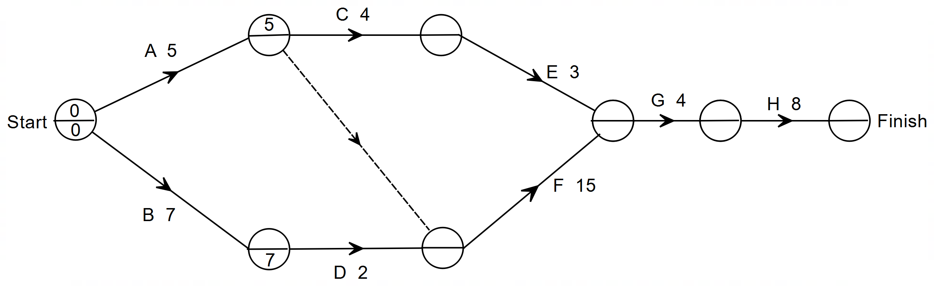 in each node. (2 marks)

(c) Determine the minimum completion time and the critical path. (2 marks)

(d) Calculate the float (slack) time for activities E and F. (2 marks)

(e) Calculate:

(i) the earliest possible starting time for activity G. (1 mark)

(ii) the latest possible starting time for activity A. (1 mark)

(f) If activity A is delayed by five hours, what effect, if any, will it have on the

completion time of the project? (1 mark)

Question 2 (8 marks)

Ten mains-powered smoke alarms (represented by the letters in the graph below) must be installed in a building. The edge weights on the graph represent the length of the cable, in metres, required between adjacent alarms.

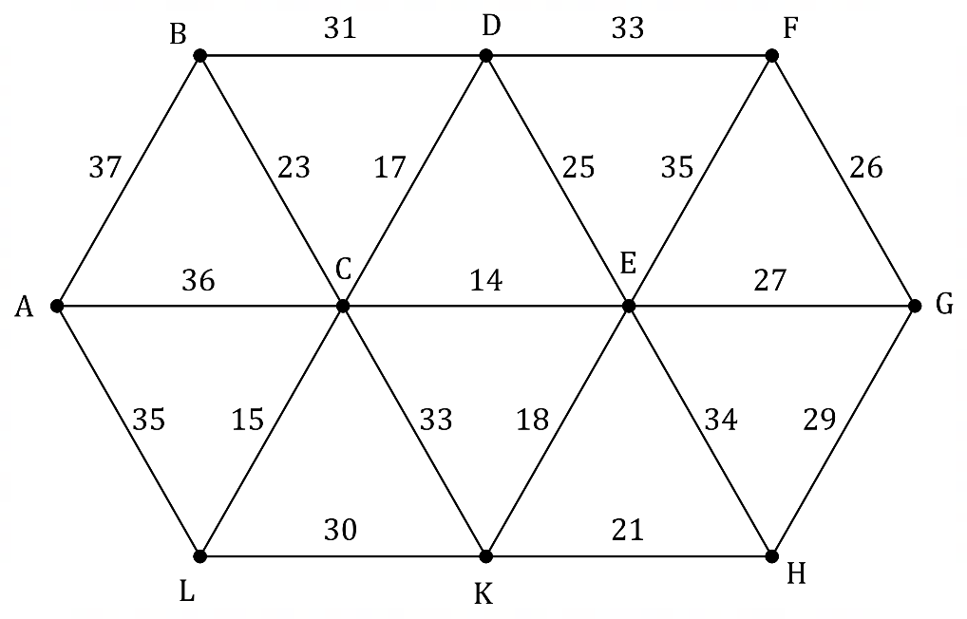

(a) Clearly identify (highlight) the minimum spanning tree on the graph above. (3 marks)

(b) Determine the cost of installing the cabling between the alarms using the minimum spanning tree, given that each metre of cabling will cost $\$21.50$. (2 marks)

(c) Explain how your answer to part (b) will change if smoke alarm $N$ is added to the system with cable lengths of $20, 25$ and $30$ metres to alarms $A, B$ and $L$ respectively.

(*A copy of the graph from the previous page is shown below if you wish to use it*.)

(3 marks)

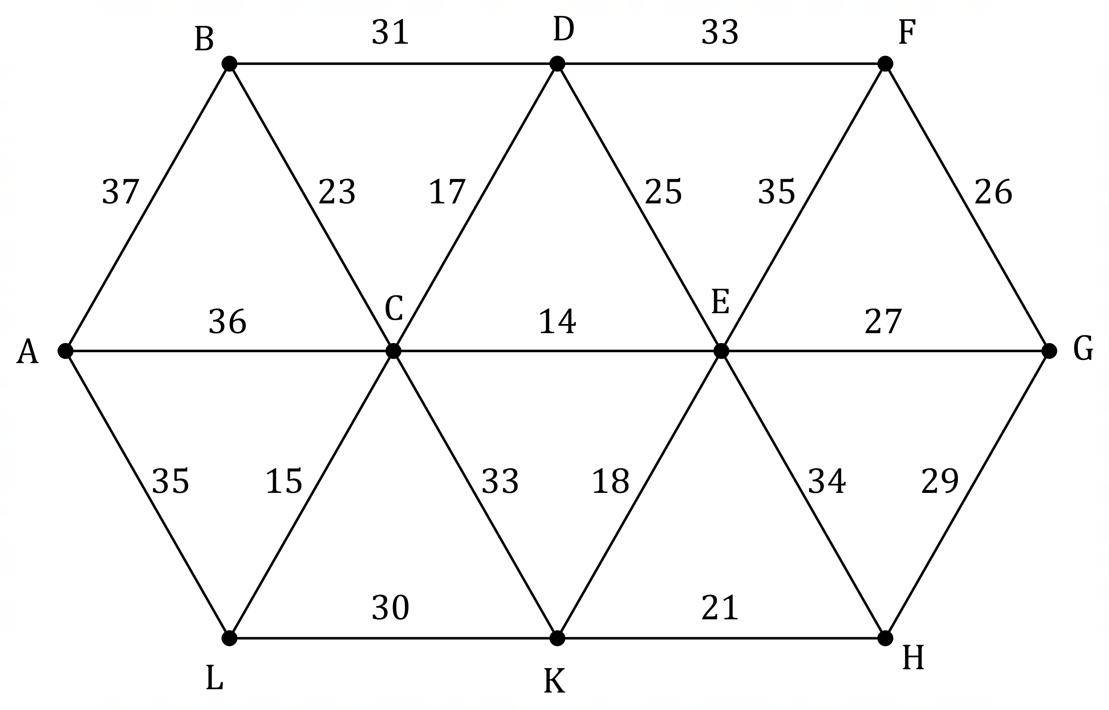

Question 3 (7 marks)

When a city bypass is closed, traffic that would normally use it is forced to flow through main roads in the city. The edge weights on the directed graph below show the maximum number of vehicles per minute that can travel between junctions (represented by vertices) without causing congestion in the city.

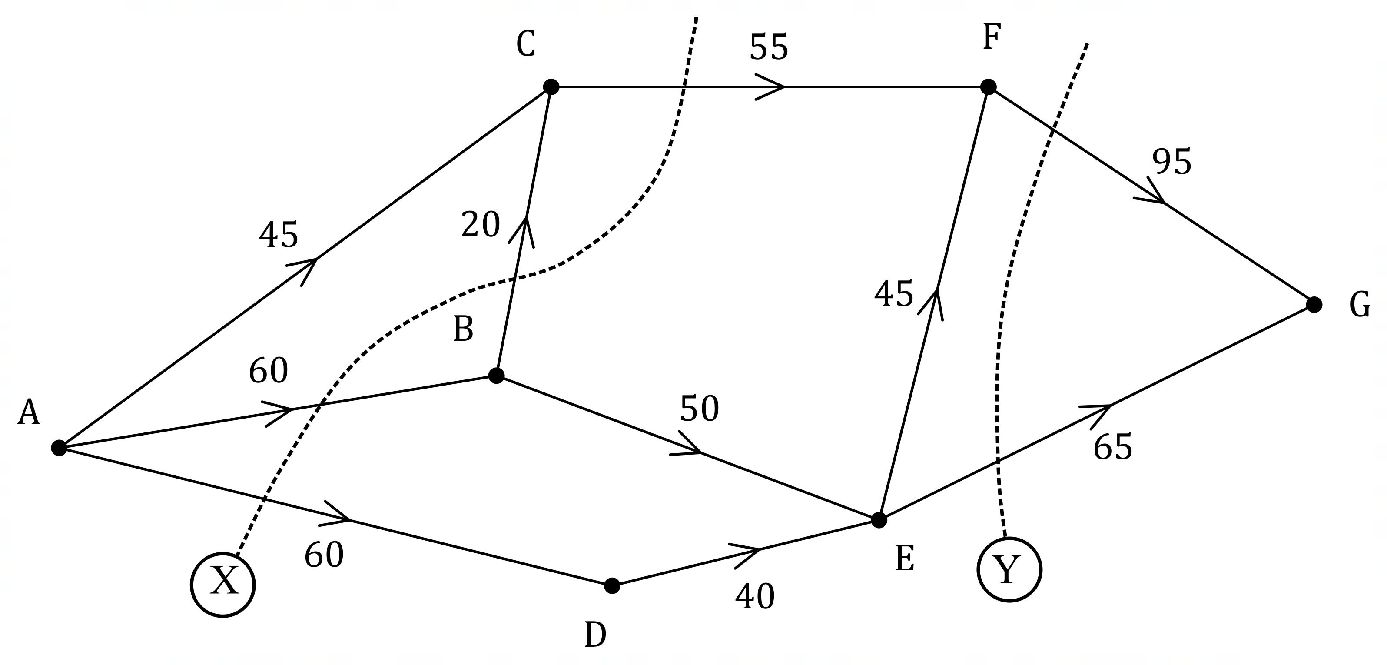

(a) Determine the value of cut $X$ and the value of cut $Y$. (2 marks)

(b) Determine the maximum flow of vehicles per hour from $A$ to $G$. (3 marks)

(c) City engineers recommend taking steps to improve traffic flow between junctions $D$ and $E$. Determine, with reasoning, the maximum increase in the hourly flow of vehicles from $A$ to $G$ that their plan could achieve. (2 marks)

**Question 4 (10 marks)**

A telemarketing company has three workers: Awis, Geme and Haikal.

These three workers are to be assigned to one of four contracts (A, B, C or D). The number of successful sign-ups is shown in the table below.

|  |  |  |  |  |
| --- | --- | --- | --- | --- |
|  | Contract A | Contract B | Contract C | Contract D |
| Awis | 16 | 12 | 8 | 18 |
| Geme | 20 | 15 | 8 | 16 |
| Haikal | 18 | 11 | 17 | 15 |

Each worker must be assigned to just one company, and no contract can have more than one worker. The company wishes to **maximise** the number of successful sign-ups.

(a) Before starting the Hungarian algorithm, two steps must be taken to re-draw the above table. Mention the two steps that need to be taken. (2 marks)

(b) Fill in the table with values after the above two steps have been taken (2 marks)

|  |  |  |  |
| --- | --- | --- | --- |
|  |  |  |  |
|  |  |  |  |
|  |  |  |  |
|  |  |  |  |

(c) Begin the process of the Hungarian algorithm to determine which contract must be given to which worker: (4 marks)

|  |  |  |  |
| --- | --- | --- | --- |
|  |  |  |  |
|  |  |  |  |
|  |  |  |  |
|  |  |  |  |

|  |  |  |  |
| --- | --- | --- | --- |
|  |  |  |  |
|  |  |  |  |
|  |  |  |  |
|  |  |  |  |

|  |  |  |  |
| --- | --- | --- | --- |
|  |  |  |  |
|  |  |  |  |
|  |  |  |  |
|  |  |  |  |

(d) Complete the table below indicating which contract is assigned to which worker.   
 (1 mark)

|  |  |  |  |
| --- | --- | --- | --- |
|  | Awis | Geme | Haikal |
| Contract |  |  |  |

(e) State the maximum number of sign-ups after the contracts have been awarded. (1 mark)

**Q5 : (2, 3 = 5 marks)**

(a) Use Prims Algorithm to determine the minimum spanning distance.

|  |  |  |  |  |  |
| --- | --- | --- | --- | --- | --- |
|  | **A** | **B** | **C** | **D** | **E** |
| **A** | - | 2 | 3 | 7 | 6 |
| **B** | 2 | - | 1 | 3 | - |
| **C** | 3 | 1 | - | 4 | 4 |
| **D** | 7 | 3 | 4 | - | 5 |
| **E** | 6 | - | 4 | 5 | - |

(b) Draw the *weighted* minimum spanning tree from your findings in (a) (i) by clearly joining the edges.

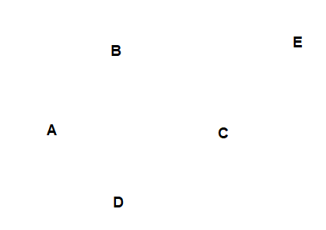

**End of Test: EXTRA WORKING PAGE**